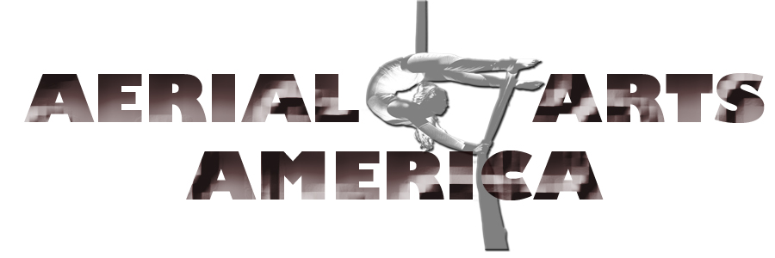
Upholding the Standards One Generation at a Time

PRESS RELEASE SEPTEMBER 27, 2014
Please join us in celebrating the 2nd Annual West Coast Aerial Arts Festival (WCAAF)
When: Nov. 14 – 16, 2014
Where: Culminating Show –YOST THEATER (Nov. 16) @ 307 N. Spurgeon Street, Santa Ana CA 92701
Competition Rounds: Aerial Dance Theater Nov. 14 – 15 @ 3001 Red Hill Avenue, Bldg. 1-107, Costa Mesa, CA 92626
AWARD COMPETITION
The competitive portion of this event comprises of at least nine (9) categories based on age (7 yrs old – seniors) and aerial apparatus catering primarily to amateur candidates. There will also be professional levels participating in divisions marked “OPEN”.
First (1st) place winners in each category receive engraved trophies; 1st place act in Overall Performance will also receive special recognition in the form of a central role in a staged production of a tier 1 festival sponsor.
WORKSHOPS: November 14 - 16
The festival will also hold workshops by guest artists highly regarded in their respective fields. The workshops offered are: Aerial Silks – Aerial Hoop – Contortion - Aerial Straps. Schedule for these workshops are available online: http://aerialartsamerica.com/workshops/
PARTICIPATION AND REGISTRATION
Participation in the competition is open to all. The registration fee is $150.00 which includes participation in one category, admission to one (1) workshop, ticket to all days and venues, printed program and souvenir T-shirt.
Deadline for submitting application packets and registration fee is October 31, 2014.
VENDOR GALLERY
The festival will feature an exciting vendor gallery showcasing businesses related to and/or supporting the aerial arts community. Please email us for vendor booth or shared table, or visit our website for additional information at www.aerialartsamerica.com
The WCAAF is a platform for all students, amateurs and semi-professionals alike, to present their skills in a competitive venue. It brings about camaraderie and recognition within and outside our community. The stories and experiences shared by each participant are collectively an achievement in and of itself, not only in support of Aerial Arts America’s mission but in building community among all of us who are touched in one way or another through their involvement. Through our competitions, our mission of promoting physical literacy is by itself directly and indirectly accomplished.
The West Coast Aerial Arts Festival (WCAAF) is a tremendous undertaking that is driven by committee directors and volunteers’ passion and support. It is funded mainly by Aerial Arts America, its sponsors and in-kind donors. We depend heavily on your endorsement and active participation - as promoters, school team competitors, and/or as donors, sponsors and program advertisers. We would be happy to discuss these types of role supports.
Let’s join hands in welcoming everyone collectively to celebrate our passion for aerial arts. We hope to see you here with us!
Visit our FAQ page: http://aerialartsamerica.com/programs/west-coast-aerial-arts-festival/faq/
___________
ABOUT AERIAL ARTS AMERICA (AAA): Established in 2012, AAA is a non-profit organization functioning as an international governing body for aerial arts. Our mission is to generate exposure for national and international talent, nurture the development of artists and performers and advocate for educational and performing arts standards in all areas of aerial arts.
We develop standards from both an educational and performing arts standpoint through 3 pillars: teacher certification, festivals and competitions as well as scholarship trainings.
Information Links:
(Check back frequently for new updates, and feel free to contact us with any questions)
- Sponsorship Levels & Pricing
- Volunteer Sign –up
- Vendor / Booth Application
- Donate

